**Capstone Project:**

**Medicare**

**Document contains:**

* Project and developer details
* Sprints planned and the tasks achieved in them
* Core concepts used in the project
* Links to the GitHub repository to verify the project completion

**Project and developer details**

**DESCRIPTION**

Create a dynamic and responsive Java e-healthcare web application for ordering medicines of different categories.

Background of the problem statement:  
Medicare is a company that supplies medicines and a couple of other healthcare essentials at an affordable price. It was established in 2012 in Delhi, India. It had been serving fine all these years, however, the business analysts noticed a decline in sales since 2017. They found out that online ordering of medicines with companies, such as 100mg and mfine are gaining more profits by eliminating middlemen from the equation. As a result, the team decided to hire a Full Stack developer to develop a healthcare web application with a rich and user-friendly interface.  
You are hired as the Full Stack Java developer and are asked to develop the web application. The management team has provided you with the requirements and their business model so that you can easily arrange different components of the application.

Features of the application:

1. Registration
2. Login
3. Payment gateway
4. Searching
5. Filtering
6. Sorting
7. Dynamic data
8. Responsive and compatible with different devices

**Admin Portal:**  
The admin portal deals with all the backend data generation and product information. The admin user should be able to:

Add or remove medicine details from the application to build a rich product line

Edit medicine details like name, price, seller, product description, and offers to keep the product information updated with the current prices

Enable or disable a medicine product

**User Portal:**  
It deals with the user activities. The end-user should be able to:

Sign-in to the application to maintain a record of activities

Search for products based on the search keyword

Apply filters and sort results based on different cuisines to get the best deals

Add all the selected food items to the cart and customize the purchase at the end

Perform a seamless payment gateway

Get an order summary details page once the payment is complete

**Developer Details**: Mogili Santhi

Santhimogili3@gmail.com

**Sprints planned and the tasks achieved in them**

There are four sprints for this project

Sprint-1: Studied the Features of application and created Git Repository.

Sprint-2: Medicare backend created using spring boot and tested backend API

Sprint-3: Medicare frontend created using spring boot and connected with backend.

Sprint-4: Medicare application all features is tested.

**Recommended technologies**

Database management: MySQL

Backend development: Java programming, Eclipse, Spring Boot

Frontend development: JSP, Angular, Bootstrap, HTML/CSS.

**Output**

1. **Starting of backend Spring Boot Application.**

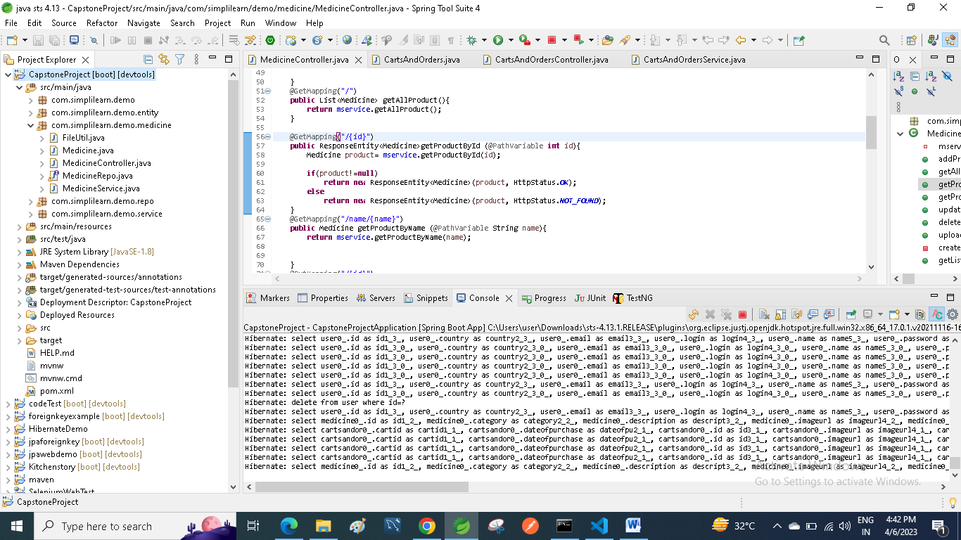

1. **opening of vs code.**

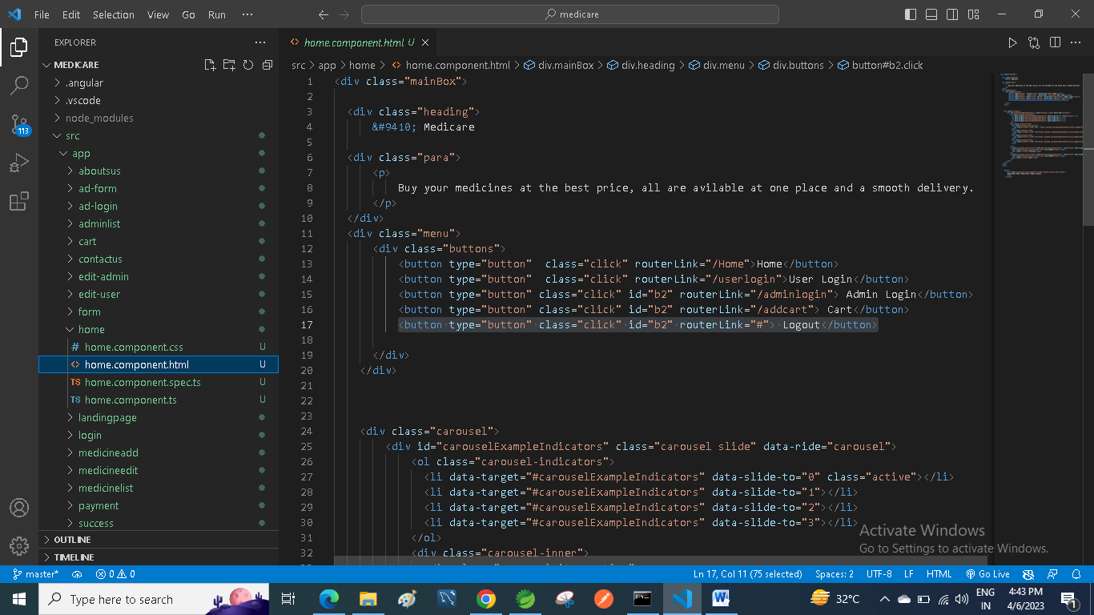

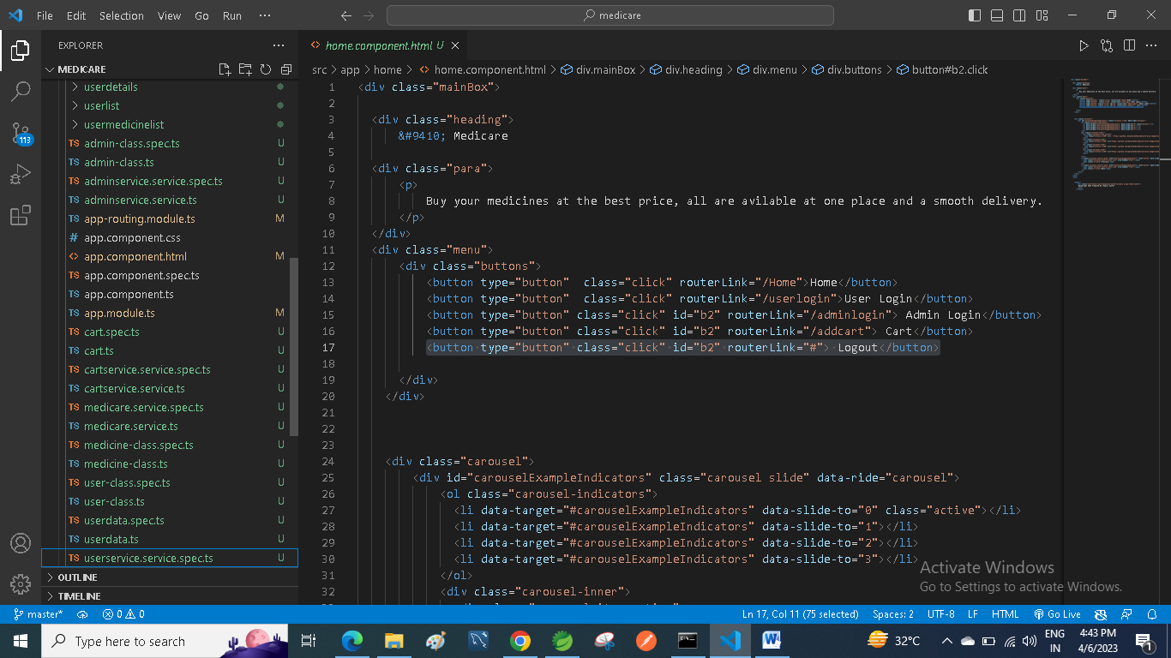

1. **opening the path in cmd and using ng serve code to start angular frontend application and Running localhost:4200/userhome url and Home page is opened.**

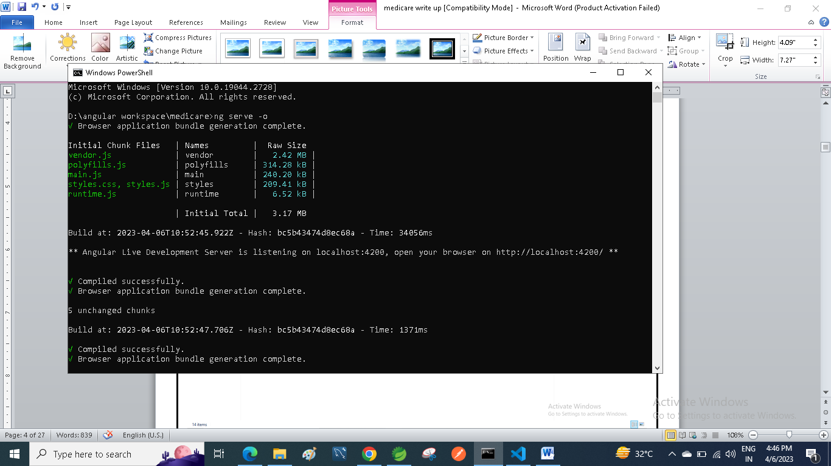

1. **Home page are shown in the website application.**

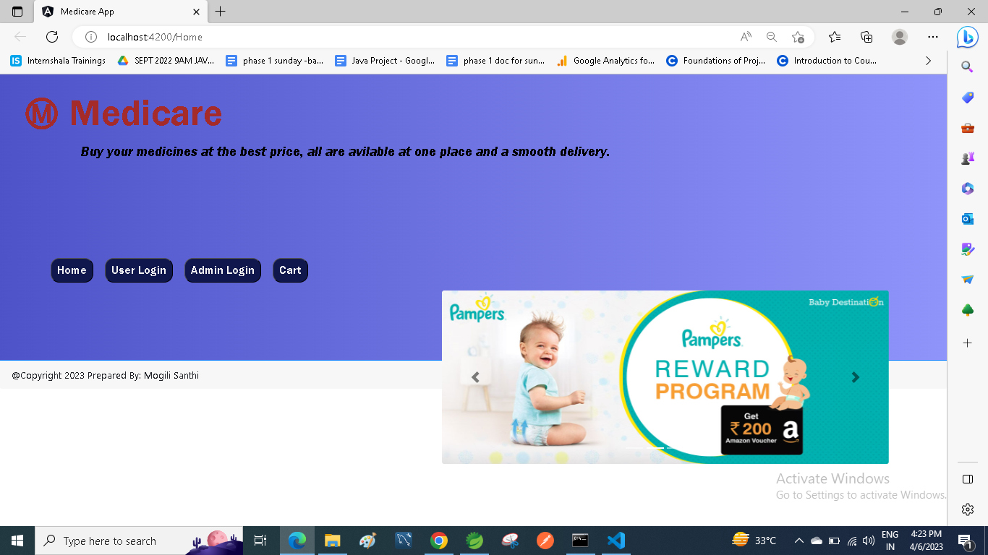

1. **Using Search it is showing product starting with name.**

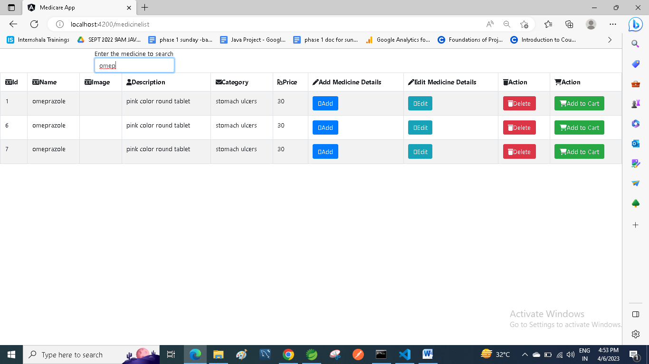

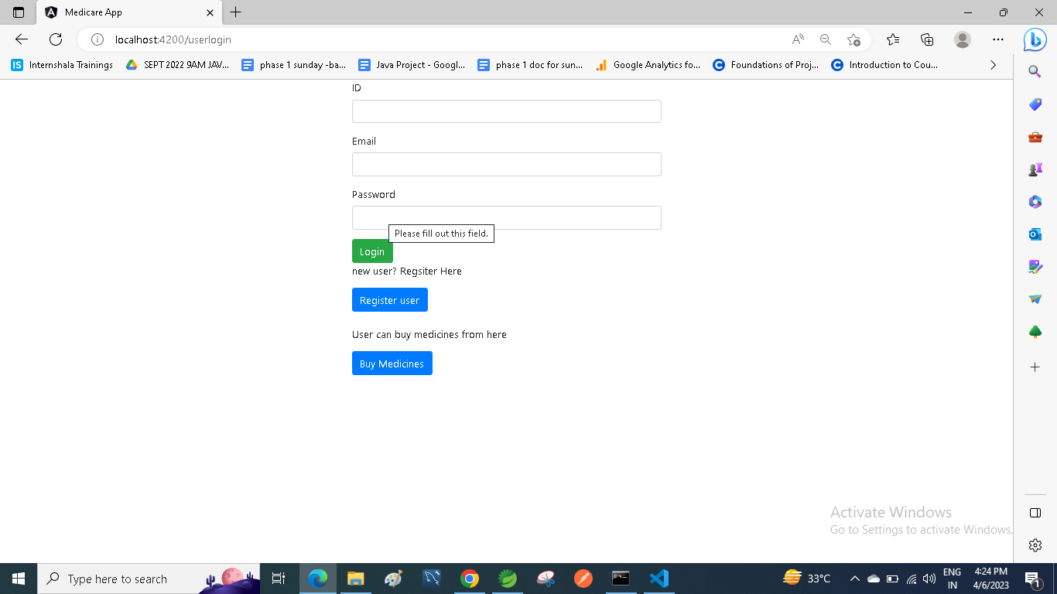

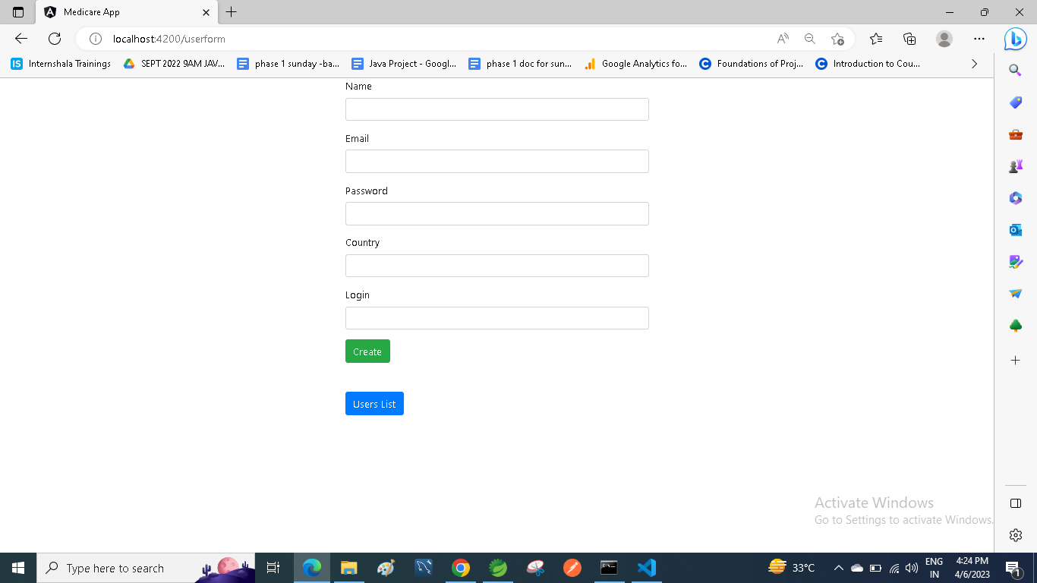

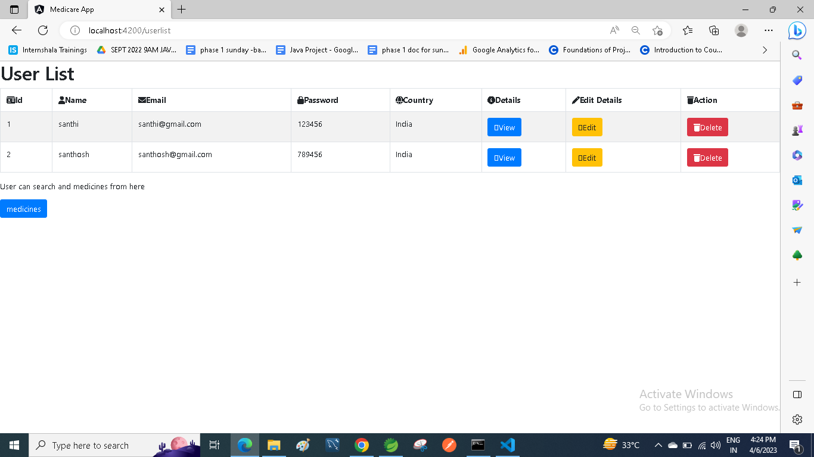

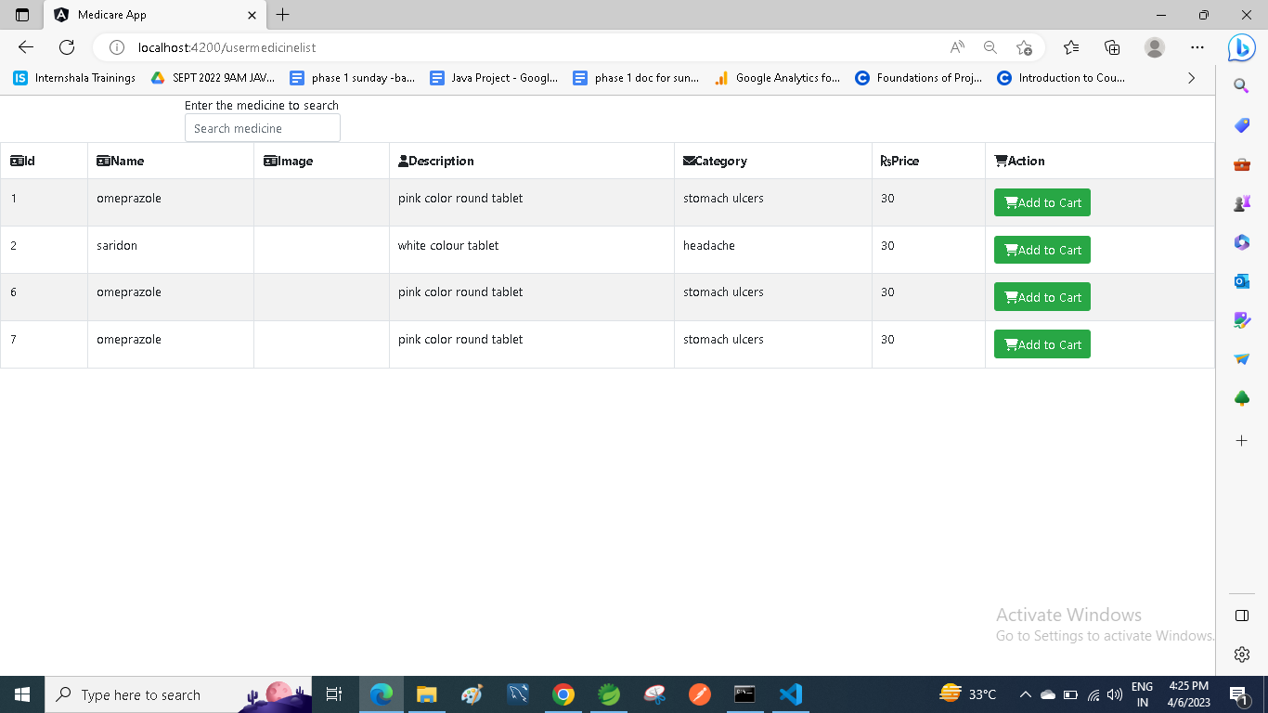

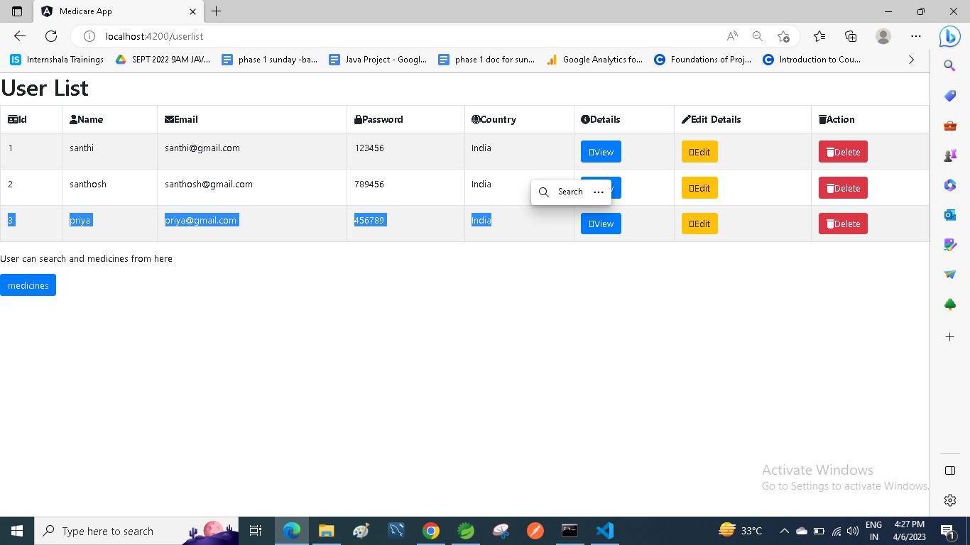

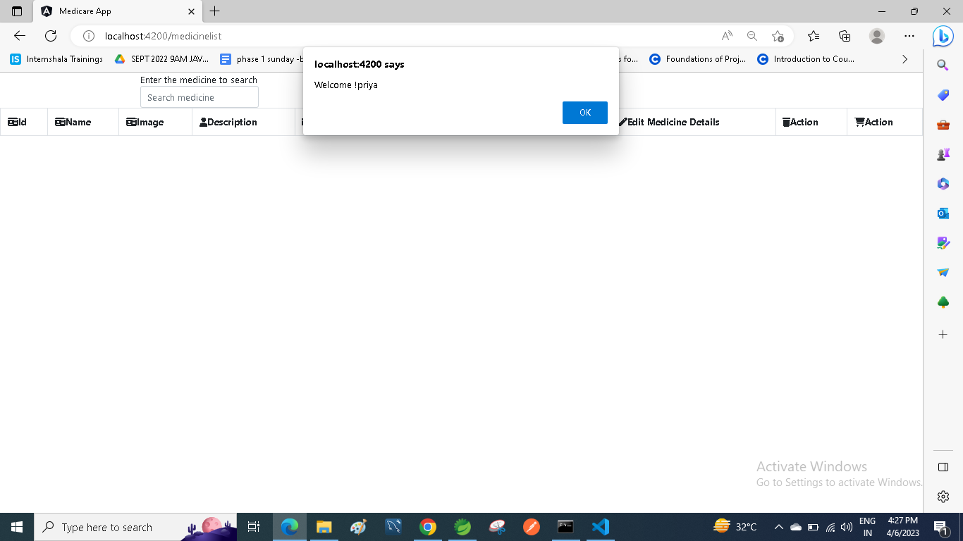

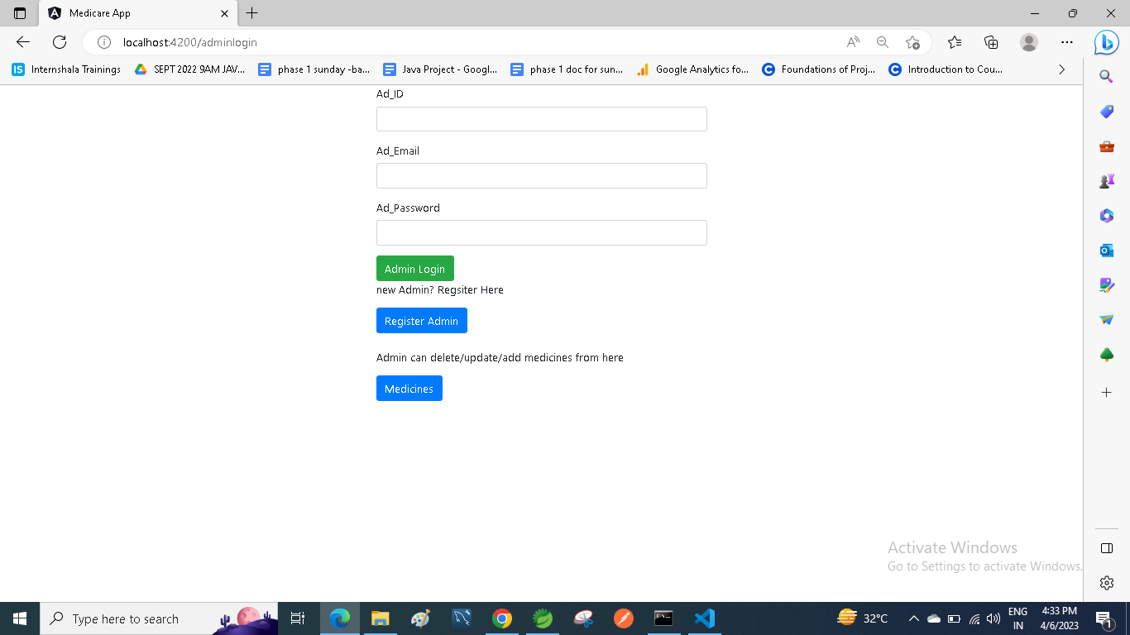

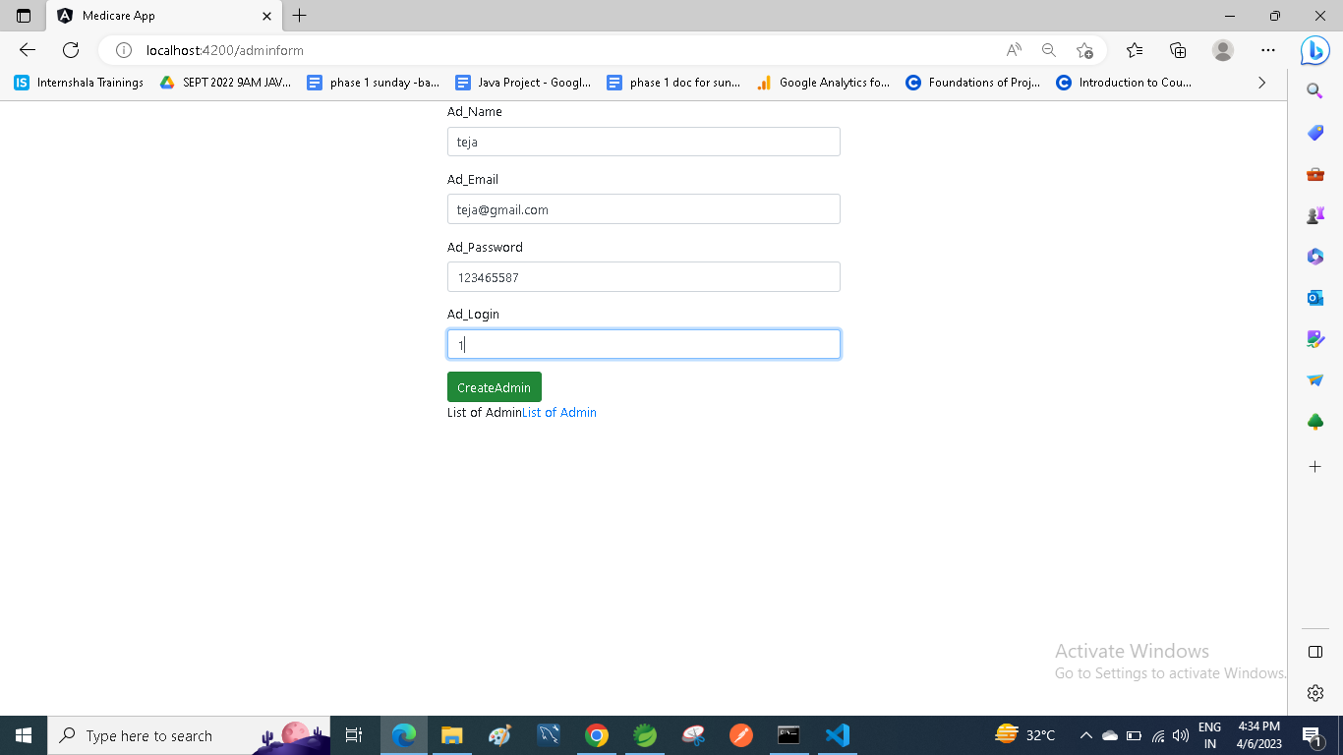

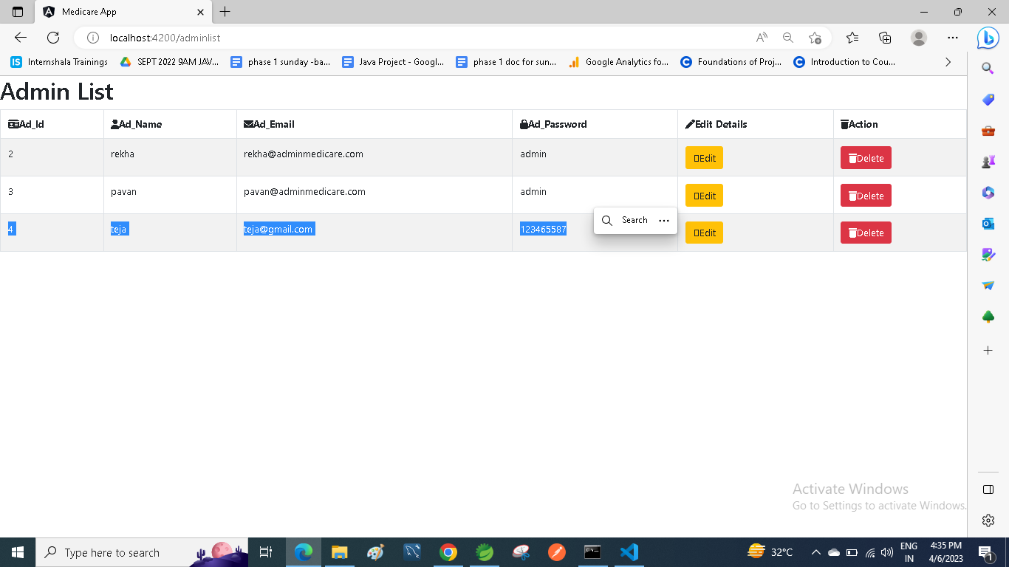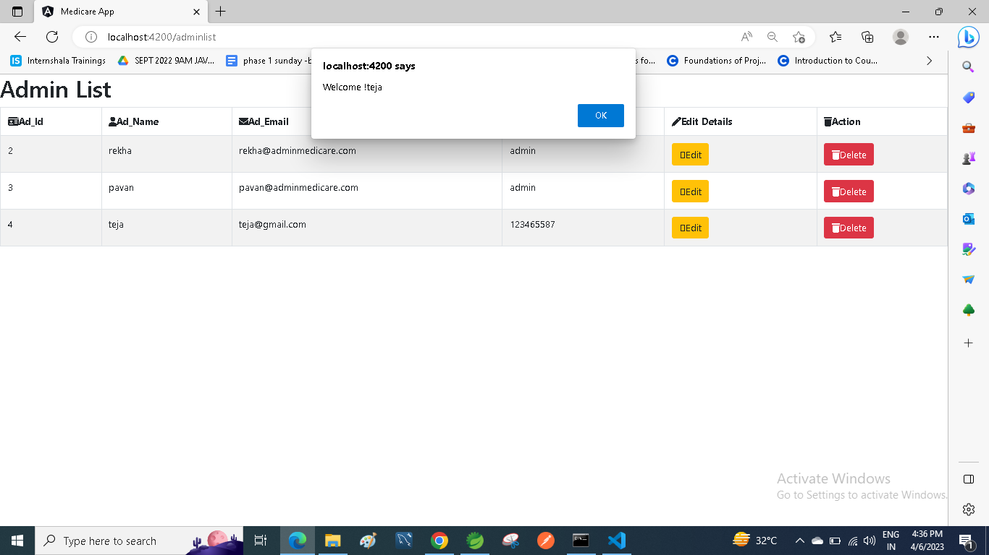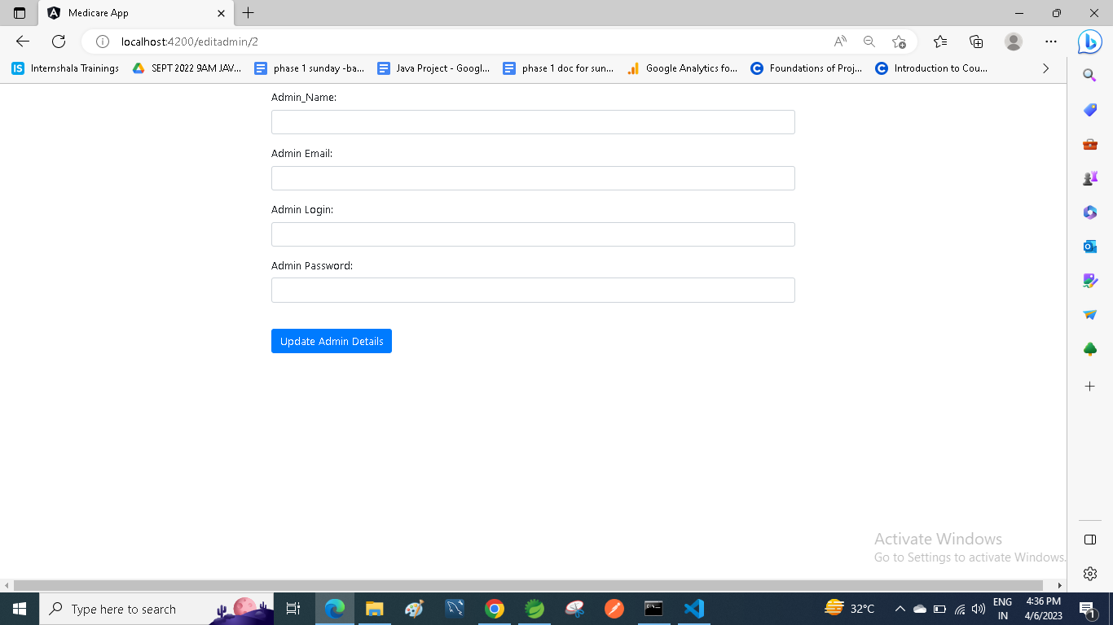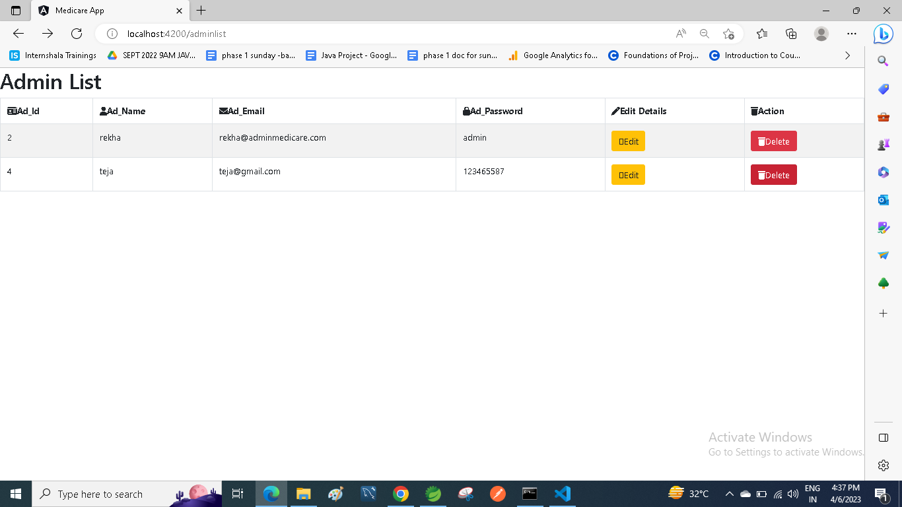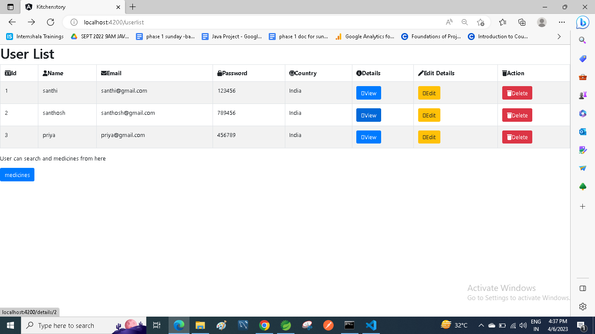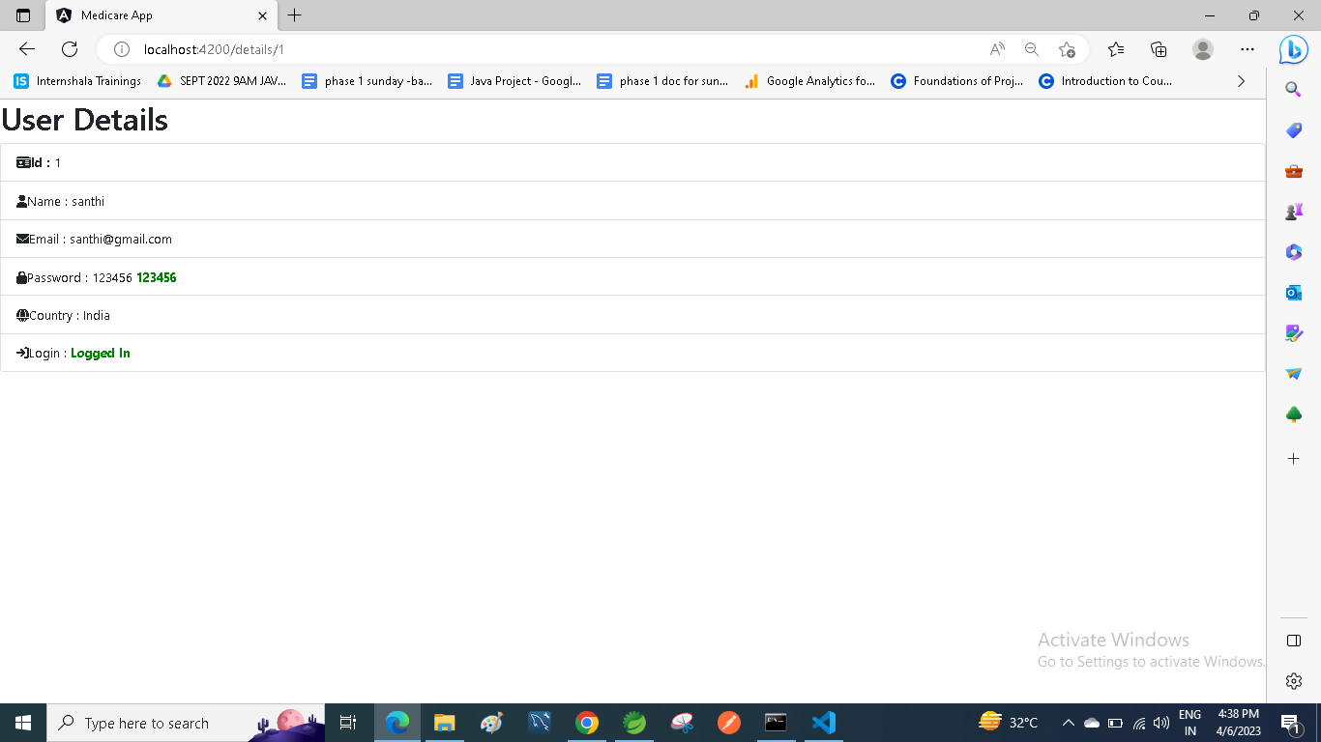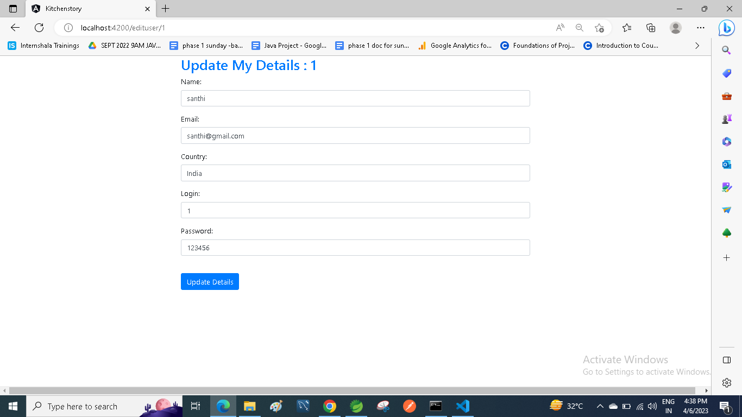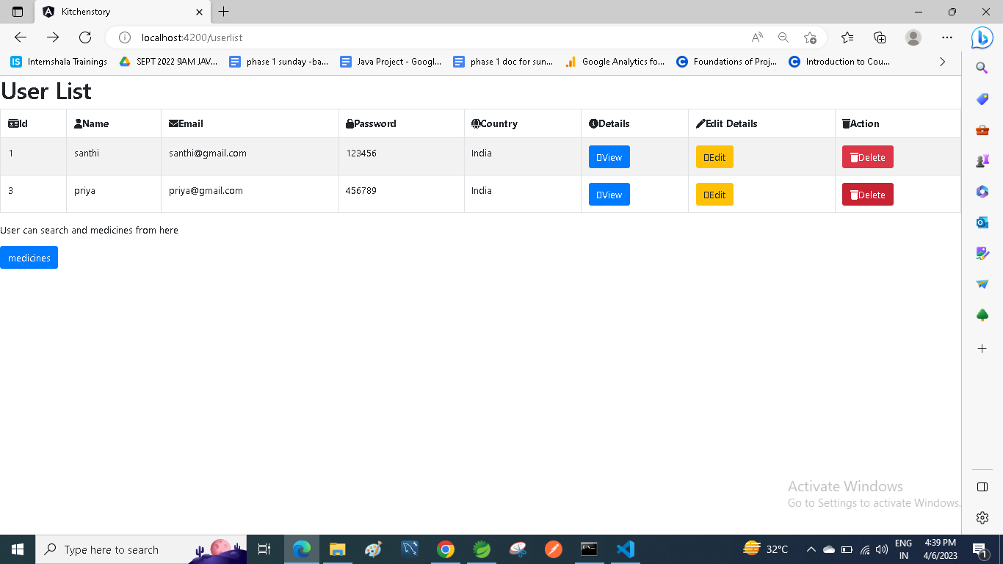

















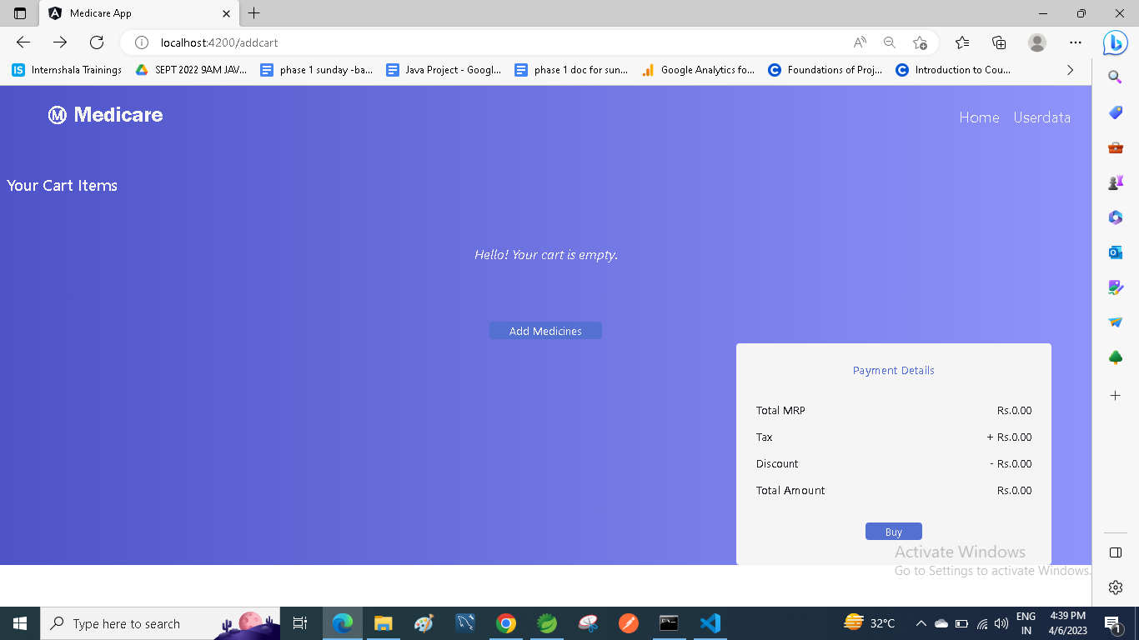

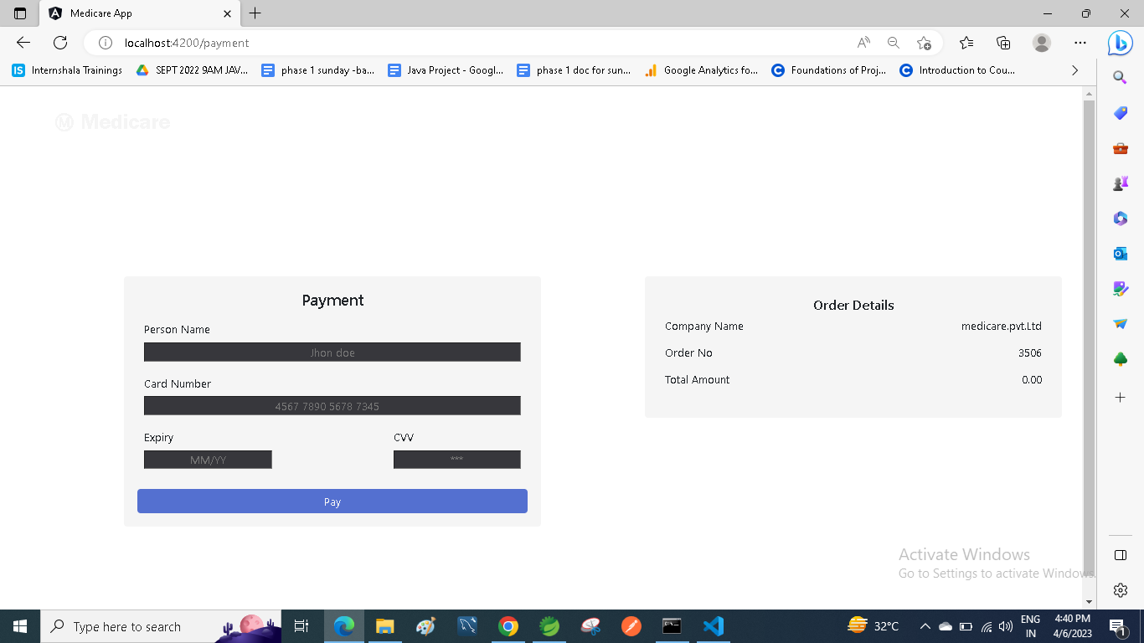

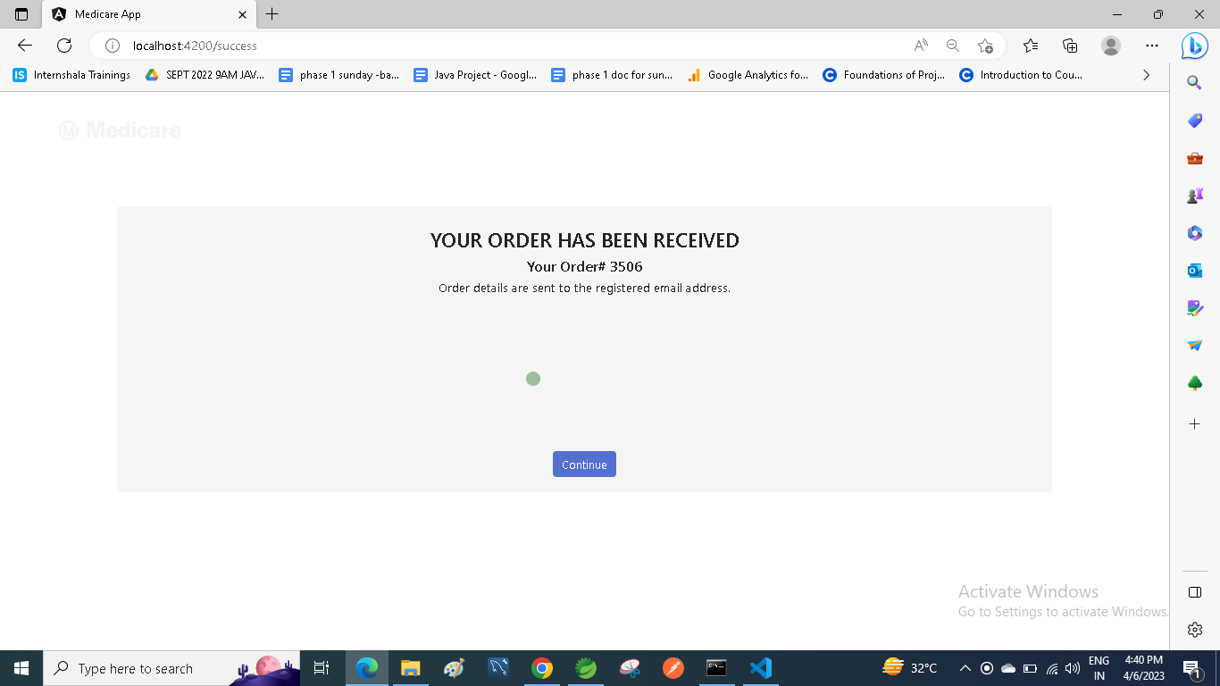

**Links to the GitHub repository to verify the project completion**

## **Pushing the code to GitHub repository**

* Open your command prompt and navigate to the folder where you have created your files.

**cd <** **D:\Medicare\File>**

* Initialize repository using the following command:

**git init**

* Remote add the repository using the following command

**https://github.com/Mogilisanthi/Simplilearn-Phase-6-Medicare_project.git**

* Add all the files to your git repository using the following command:

**git add .**

* Commit the changes using the following command:

**git commit . -m “Medicare project”**

* Push the files to the folder you initially created using the following command:

**git push -u origin master**